Discovering GANs – Exploring the latent space
Structure de quadrilatères, Vera Molnar, 1985
Tristan Debeaune & Wendy Gervais

We used the generator.h5 file to explore our GAN’s latent space, i.e see how points evolve within the possibilities of positions, between two samples.

It took the form of little gif animations, colored or B&W, using the inference notebook.

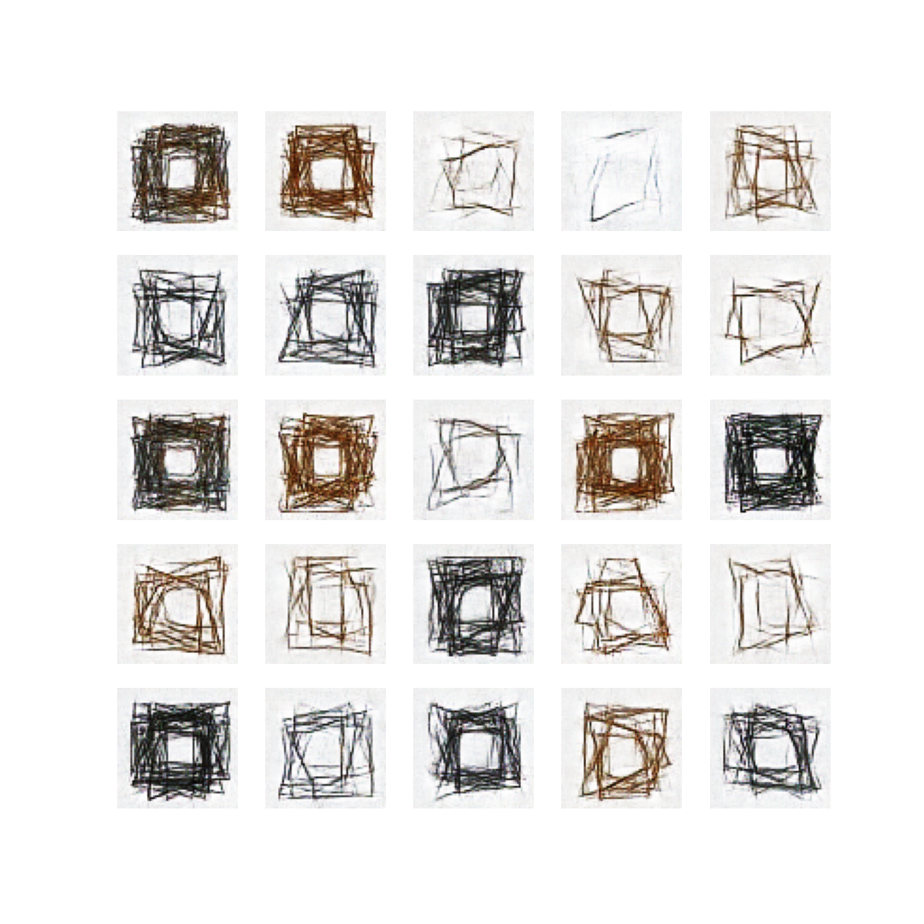


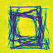
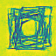


We also could try improving the resolution of our images :

